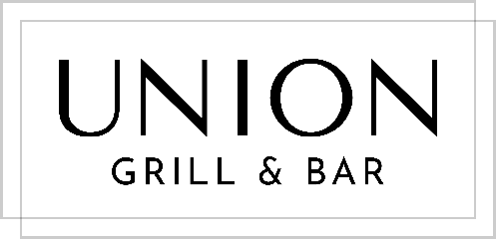

BUBBLES BY THE GLASS 150ml

Champagne, Billecart Salmon, Extra Brut Zero Dosage, France $18
Prosecco, 7 Cascine, Veneto Italy $10
Cava Rosé, Pares Balta, Spain $15

WINES BY THE GLASS 175ml | 250ml

WHITE

Vermentino, Melaccie, Tuscany, Italy, 2019 $ 9 / $13
Sauvignon Blanc, Barking Hedge, New Zealand, 2019 $11 / $15
Grüner Veltliner, Loimer, Kamptal, Austria, 2019 $12 / $17
Chardonnay, Rodney Strong, Chalk Hill, U.S.A, 2017 $12 / $17
Sancerre, Michel Girard & Fils, France, 2018 $14 / $20

ORANGE

Greco, Ispirazione, Valentina Passalacqua, Puglia Italy, 2019 $14 / $20

ROSÉ

Grenache Blend, Château Minuity ‘M’, France, 2019 $11 / $15
Garnacha, Musso de Casarojo, Valladolid, Spain (vegan), 2018 $10 / $14

RED

Malbec, Montes, Kaiken, Mendoza, Argentina, 2018 $9 / $13
Sangiovese, Montecucco, Tuscany, Italy, 2016 $11 / $15
Pinot Noir, Cooper Hill, Oregon, U.S.A, 2019 $12 / $17
Cabernet Sauvignon, Duckhorn, Decoy, California, U.S. A, 2018 $15 / $22
Super Tuscan, Querciabella, Mongrana, Italy, 2015 $16 / $23

CLASSIC APERITIFS

Vesper Martini $12
Hendricks & Tonic $12
Negroni Cocktail $12

Ricard Pastis $10
Aperol Spritz $12
Campari Cinzano $12

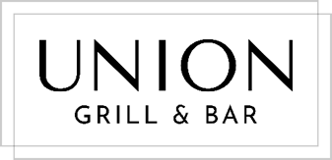

SHARING

ROASTED NUTS (gf) $5
Asian spices, shallots, herbs

BREAD (gfo) $6
artisan breads, butter

GORDAL OLIVES (ve, gf) $5
citrus marinade

APPETIZERS

BRUSCHETTA ‘LIGURIA’ (ve, gfo)
chargrilled Mediterranean vegetables, black olive tapenade, focaccia
$11

CITRUS BURRATA (v, gf)
torched orange, honey lavender infusion, toasted cilantro seeds
$14

TRUFFLE MUSHROOM PATE (v, gfo)
porcini & oyster mushrooms, truffle oil, cornichons, sourdough toast
$14

‘CIELO ROJO’ FISH CEVICHE (gf)
mezcal, clamato, serrano green chilli, plantain chips
$16

enjoy your ceviche with a Dutch Courage cocktail $13
Ketel One vodka, fresh tomato blitz, black pepper, lemon

TUNA TARTARE (gf)
avocado, mango, house ponzu, cucumber & melon gazpacho
$18

BEEF TARTARE (gfo)
hand-cut CAB tenderloin, egg yolk, truffle crumb, smoke dome, sourdough toast
$19

DUCK SALAD (gf)
smoked duck, crispy skin, watermelon, pickled blackberries, spiced cashews, mint, Asian dressing
$17

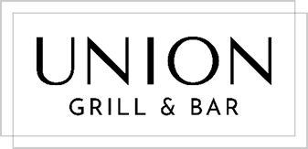

STEAKS

CERTIFIED ANGUS BEEF (gf)
ON THE LAVA ROCK GRILL

All our steaks are marinaded in herbs, garlic and olive oil for 24 hours,
then seared to perfection on the lava rock grill.

Price includes one side and one sauce (excludes lobster mac ‘n’ cheese).

TENDERLOIN
8oz $46

NEW YORK STRIP
14oz $44

RIBEYE
12oz $45

RANCH & REEF
6oz tenderloin + whole lobster tail
$46

SAUCES

bearnaise (v, gf) | creamy mushroom (gf) | green peppercorn (gf)| chimichurri (ve, gf)
additional sauce $4

SIDES

house fries (ve, gfo) $4 | parmesan truffle fries (v, gfo) $6

potato dauphinoise (v, gfo) $6 | mash potato (v, gf) $5 | mac ‘n’ cheese (v) $5

asparagus (gf) $6 | broccolini (gf) $7 | French beans (gf) $6 | green salad (gf) $5

DELUXE LOBSTER MAC ‘N’ CHEESE
sharp English cheddar, pan-seared lobster tail, toasted crumb
$12

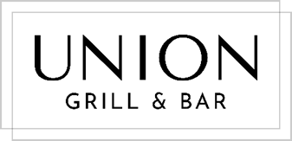

BURGERS

all burgers served with either a brioche bun, gluten free bun or lettuce ‘wrap’
add: fries $3 parmesan truffle fries $5 crisp green salad $5

CLASSIC BEEF (gfo)
triple blend patty (brisket, chuck, sirloin)
bacon, onion jam, pickles, chipotle mayo, iceberg, tomato
$16
make it a cheeseburger: Gruyere, Cheddar, Blue $4

GREEK LAMB (gfo)
seasoned lamb patty
feta tzatziki, onion jam, shaved cucumber, arugula
$18

PLATES

CHICKEN SUPREME
tarragon brioche pudding, braised pancetta peas, chicken jus
$27

SLOW-BRAISED LAMB SHANK
mash potato, sauteed leeks, dark stout reduction
$28

PORK TENDERLOIN (gf)
pistachio crust, cauliflower puree, spiced red cabbage, wine jus
$28

MESQUITE-SMOKED FISH CAKE
house-made tartare sauce, fries, petite salad
$22

PAN-SEARED RED SNAPPER (gf)
asparagus, zucchini, French beans, sprouts, crushed potato,
warm pesto cream sauce
$28

BARBECUED PERI-PERI SKEWERS (ve, gf)
tofu, pineapple, green bell pepper, peri-peri sauce, black rice
$20

(v) = vegetarian, (ve) = vegan, (gf) = gluten free, (gfo) = gluten free option available
Please advise your server of any dietary restrictions prior to ordering. All prices are in CI$: 1 CI$ = 1.25 US$.
For your convenience, a 15% gratuity charge will be added to all checks.

