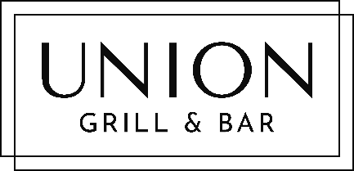

Premium Drinks Package
Premium Wine, Spirits, Beer
& Cocktails

First 3 Hours CI$45 p/person
Subsequent Hours Based on Consumption

Moscato d’Asti, Batasiolo, Italy
Sauvignon Blanc, Babich, NZ
Chardonnay, Rodney Strong, USA
*
Rose, Château Minuity, France
Pinot Noir, Pays D’Oc, France
Cabernet Sauvignon, Submission, USA
Malbec, Alamos, Argentina
*
Prosecco, Il Coulture

Spirits & Mixers
Stolichnaya Vodka, Bacardi White Rum, Legacy Dark Rum, Gordan’s Gin
Johnny Walker Red Label
Coke, Diet Coke, Sprite, Ginger Ale, Franklin Tonic, Club Soda, Fruit Juices

Beers
Caybrew, Michelob Ultra, Heineken, Shellshock IPA

2 Cocktail Choices
Cosmopolitan, Old Fashioned

Bottled Water, Teas & Coffees Charged Extra

